Test Case/s to be automated

Contents

Add Customer 1

Pre-requisites 1

Test setup: 1

Test case 1: GIVEN invalid data entered THEN warning message displayed 2

Test case 2: GIVEN invalid data entered WHEN Submit button is pressed THEN alert 3

Test case 3: GIVEN valid data entered WHEN Submit button is pressed THEN id displayed 4

Check point 4

# Add Customer

## Pre-requisites

Ensure you are working and pushing to your own branch

Create a new package called something like **Telco project**

Please make use of test NG annotations

## Test setup:

Navigate to <http://demo.guru99.com/telecom/index.html>

Select Add Customer

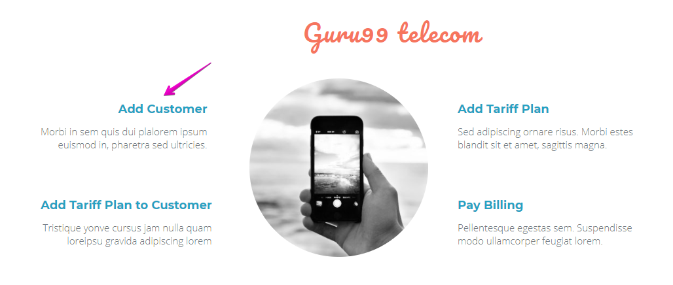

Assert that the Heading is Guru 99 Telcom and Add Customer

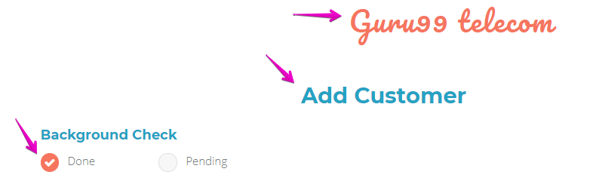

Select Done to the Background check prompt

## Test case 1: GIVEN invalid data entered THEN warning message displayed

Fill in the rest of the input fields with invalid data

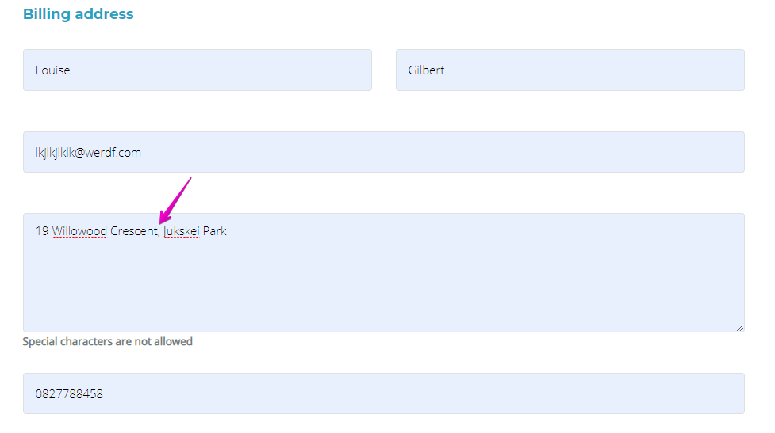

Expected result:

Warning message displayed

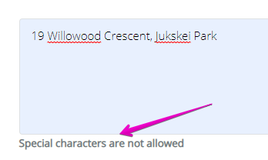

## Test case 2: GIVEN invalid data entered WHEN Submit button is pressed THEN alert

Fill in the rest of the input fields with invalid data



And click submit

Expected result:

Ensure that text is displayed as “please fill all fields”

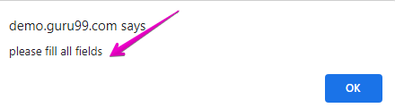

Handle the alert

## Test case 3: GIVEN valid data entered WHEN Submit button is pressed THEN id displayed

Fill in the rest of the input fields with valid data and press submit

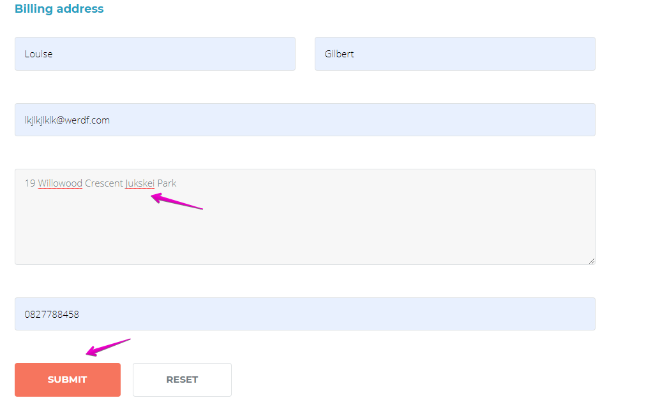

Expected result:

Check that customer ID is displayed

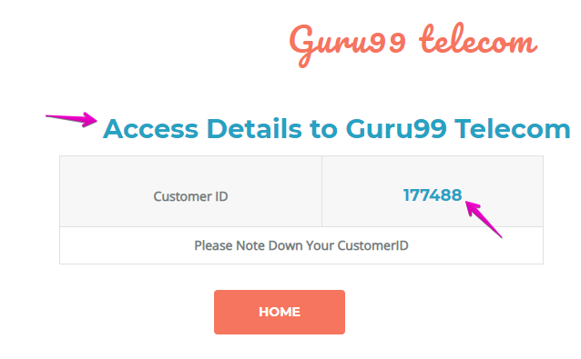

Add the customer id to a variable for later use

## Check point

Push your updates to your branch and ask a friend to have a look at it or do a demo